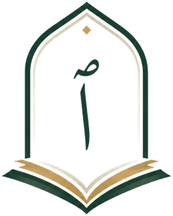
IQRA 1447
Level 1 · Game Sheets · Teacher’s Guide
Nothing on these sheets needs marking. Each one shows its own mistakes.
Hidden Pictures — 15 pages, one child each
• Read the color rules out loud once. Each child reads every box out loud, then colors it by the rules.
• To check, glance from the front of the room. A clean picture means every box was read right. A colored box out in the white, or a white box inside the picture, is a box read wrong: point to it, the child reads it to you and fixes it.
• Two or three crayons and a pencil are all a child needs. Black-and-white copies are fine: the colors are named on the sheet, never printed.

Page | Section | What it practices | Hidden picture
1 | 1 · The Letters | ب and ج among other letters | a crescent moon and a star
2 | 1 · The Letters | م and ف among other letters | the Kaaba
3 | 2 · Letters That Look Alike | ت and ث among ب ن ي | a masjid
4 | 2 · Letters That Look Alike | ج and ر among ح خ ع غ ز د ذ | a palm tree
5 | 2 · Letters That Look Alike | ص ش ض among س ط ظ | a bee
6 | 2 · Letters That Look Alike | ذ and ز among د ر | an ant
7 | 3 · Harakat | Fat-ha and Damma (Kasra stays white) | a lantern
8 | 3 · Harakat | Kasra and Damma (Fat-ha stays white) | an elephant
9 | 3 · Harakat | Sukoon and Kasra among Fat-ha and Damma | a Mushaf on its stand
10 | 4 · Tanween | Tanween Fath and Tanween Damm among single harakat | a sailboat
11 | 4 · Tanween | Tanween Kasr and Tanween Fath among single harakat | a fish (the fish of Yunus)
12 | 5 · Natural Madd | Madd Alif and Madd Yaa among short harakat and Madd Waaw | a flower
13 | 5 · Natural Madd | Madd Waaw and Madd Alif among short harakat and Madd Yaa | a pen (Al-Qalam)
14 | 6 · Shadda | Shadda with Fat-ha and with Kasra among no Shadda | a kite
15 | 6 · Shadda | Shadda with Damma and with Fat-ha among no Shadda | a prayer rug
Make Your Own Bingo — 6 pages, the whole class at once
• Each child copies any 9 boxes from the bottom of the sheet into the card. Every card comes out different, and the copying is writing practice.
• Call the boxes in any order from one copy, ticking each as you call it. Sections 1 and 2: say the letter’s name. Sections 3 to 6: read the box out loud.
• The first child with three in a row says “Bingo!” and reads the row out loud. You check by ear — that is all the checking there is. Play on for more winners, or for a full card.
• Anyone who reads well can do the calling: a helper, or an older student.
Connect the Dots — 3 pages, one child each
• The order is printed under the title, right to left, and every child already knows it: the alphabet song; then Fat-ha, Damma, Kasra on each letter; then the three tanween on each letter. Start at the dot with a ring, and end back at it.
• To check, look at the figure. A dot taken out of order is a line that cuts across the picture.
• When the figure is done, the child colors it in and says or writes what it is.

Page | Section | The order | The figure
1 | 1 · The Letters | the alphabet song | a masjid
2 | 3 · Harakat | Fat-ha, Damma, Kasra on each letter, from ب to ر | a crescent moon
3 | 4 · Tanween | Tanween Fath, Damm, Kasr on each letter, from ب to ذ | ۞, the Rub el Hizb star that marks each quarter of a hizb in the Mushaf
The answers
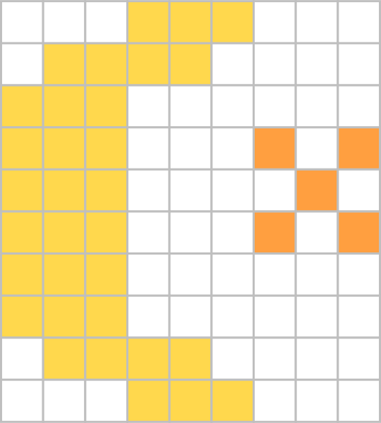  1 crescent moon and a star | 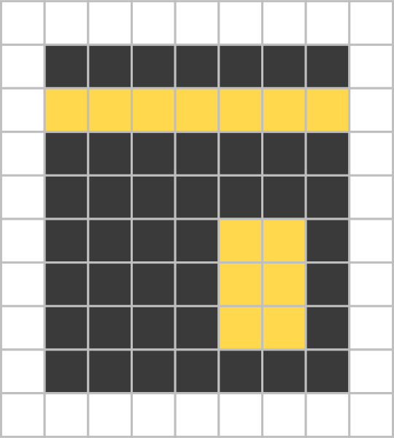  2 Kaaba | 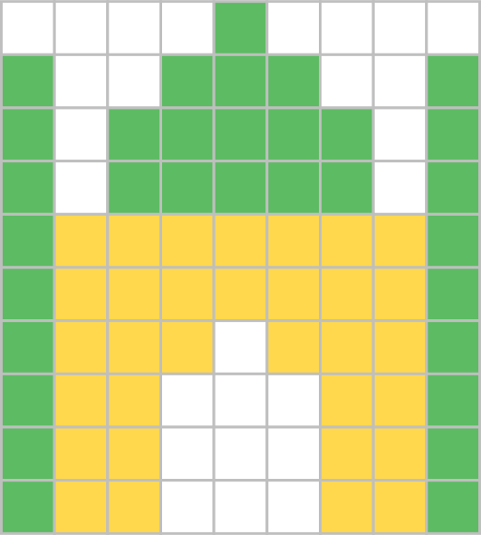  3 masjid | 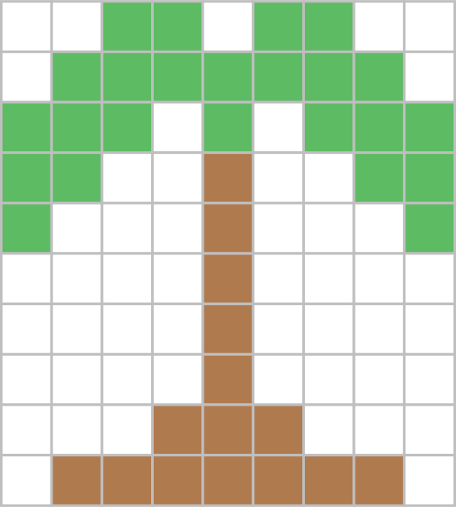  4 palm tree | 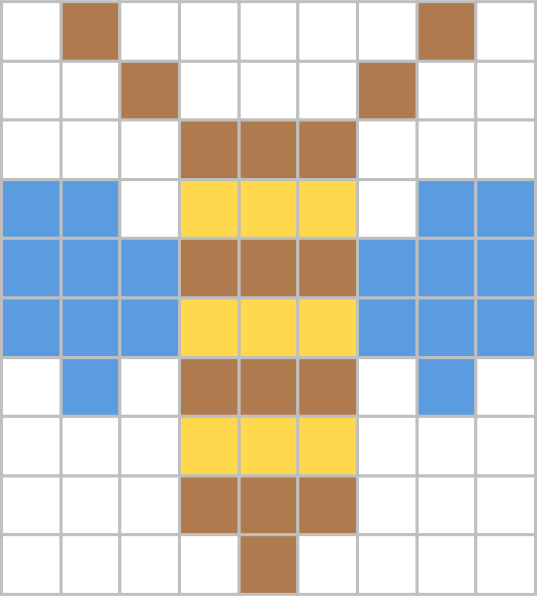  5 bee | 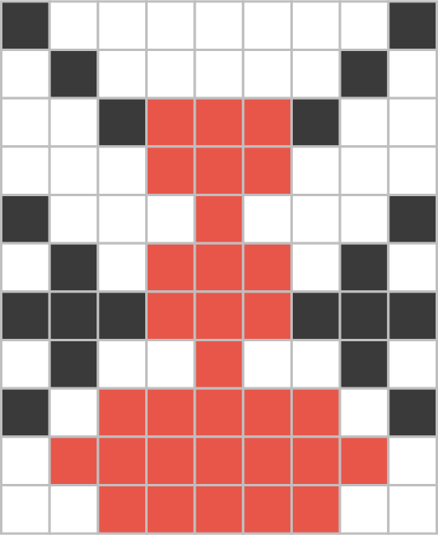  6 ant | 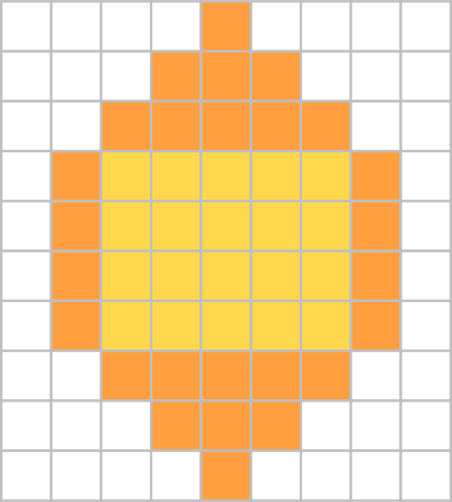  7 lantern | 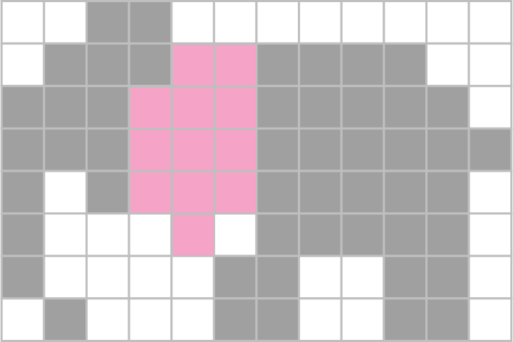  8 elephant
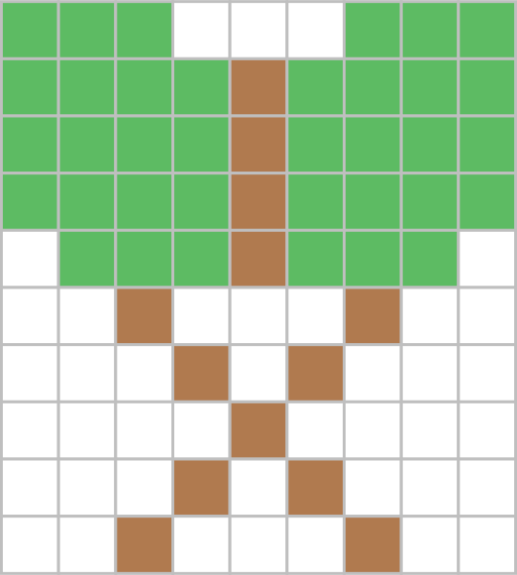  9 Mushaf on its stand | 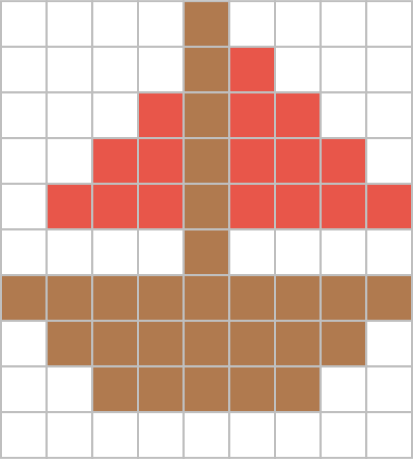  10 sailboat | 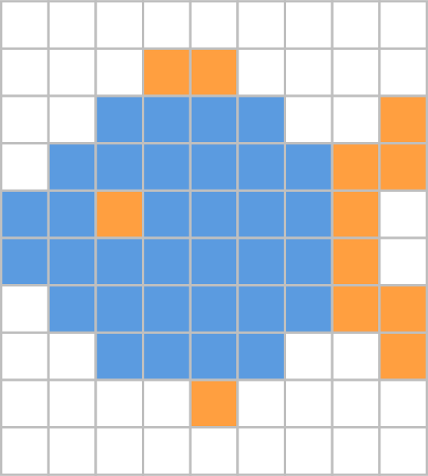  11 fish | 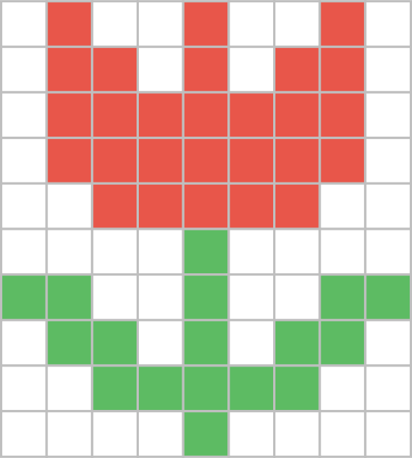  12 flower | 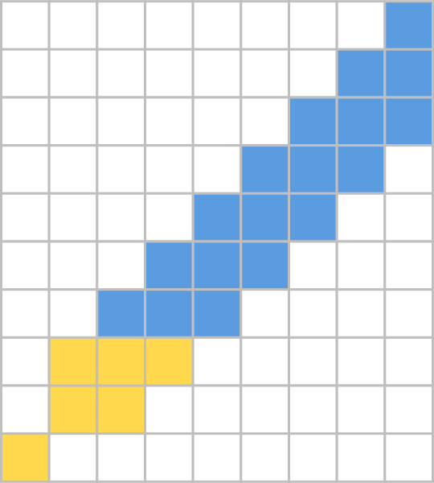  13 pen | 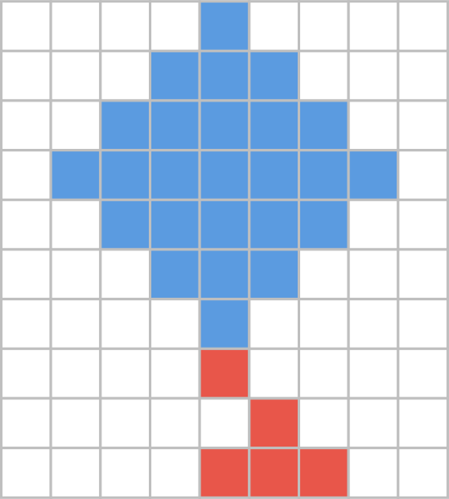  14 kite | 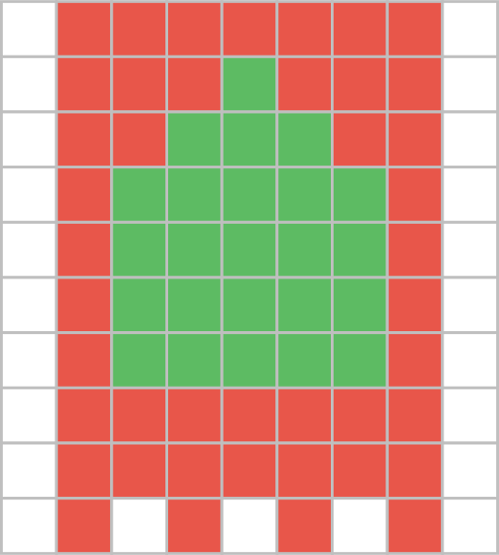  15 prayer rug

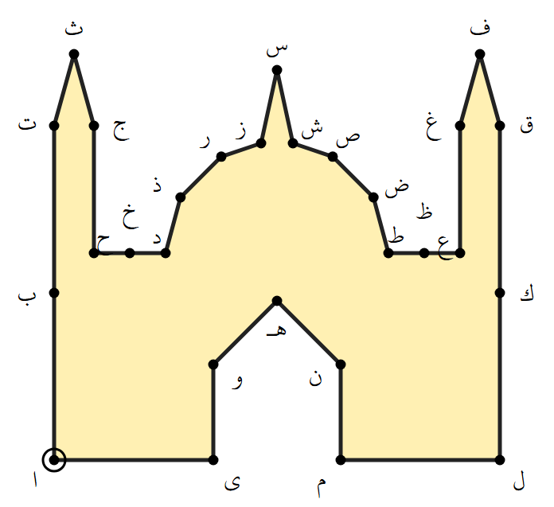  1 masjid | 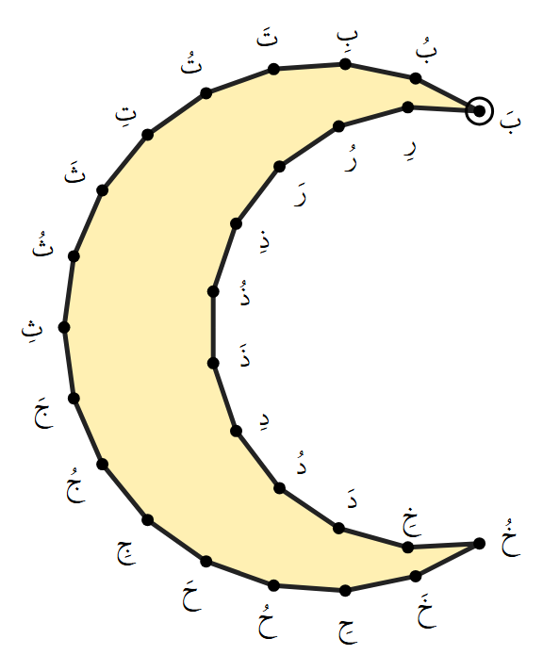  2 crescent moon | 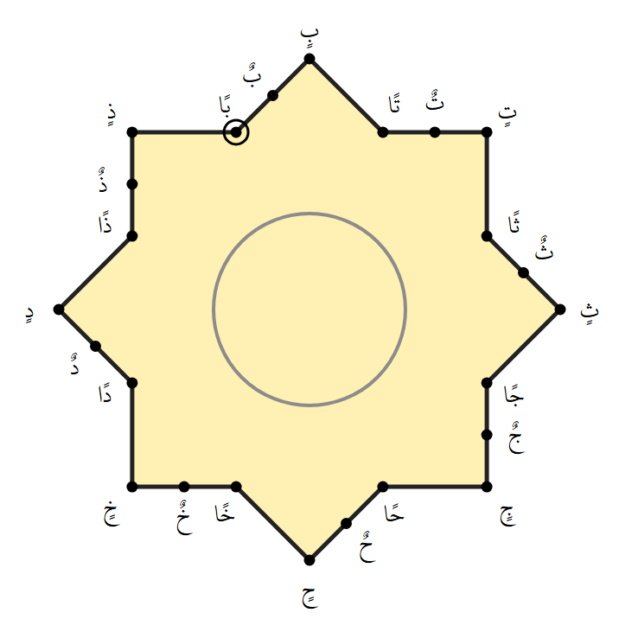  3 Rub el Hizb star

